***VALIDTION REPORT***

***HTML***

I corrected this error line of code by:

<!DOCTYPE html>

<html lang="en">

<head>



I corrected this error by:

<a href="#Education_Experience" class="w3-bar-item w3-button w3-text-grey w3-hover-black" onclick="closeNav()">Education & Experience</a>



I could not correct this one because in vs code the path to link each project is that way.

 <a href="project/Week 1/Week 1/index.html">

          <img src="Photos/webdesign1.png" alt="webdesign" class="w3-row-padding" id="webdesign">

        </a>

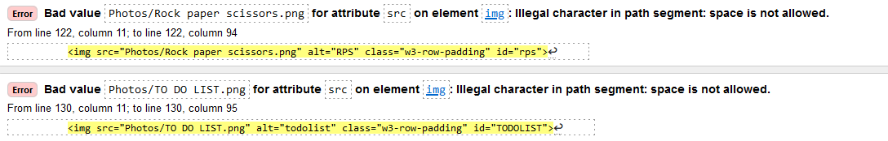

These two errors I corrected them by removing the spaces and renaming the photos

 <a href="project/Rps/RPS_0.html">

          <img src="Photos/RPS.png" alt="RPS" class="w3-row-padding" id="rps">

 <a href="project/todo_list(1)/todo_list/todo.html">

          <img src="Photos/TODOLIST.png" alt="todolist" class="w3-row-padding" id="TODOLIST">

        </a>

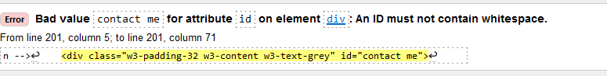

I corrected this one by:

<div class="w3-padding-32 w3-content w3-text-grey" id="contact-me">



I corrected this one by renaming it also:

 <a href="project/week 2/rawtext.html">

          <img src="Photos/webpageDesign.png" alt="webpage" class="w3-row-padding" id="webpage">

        </a>

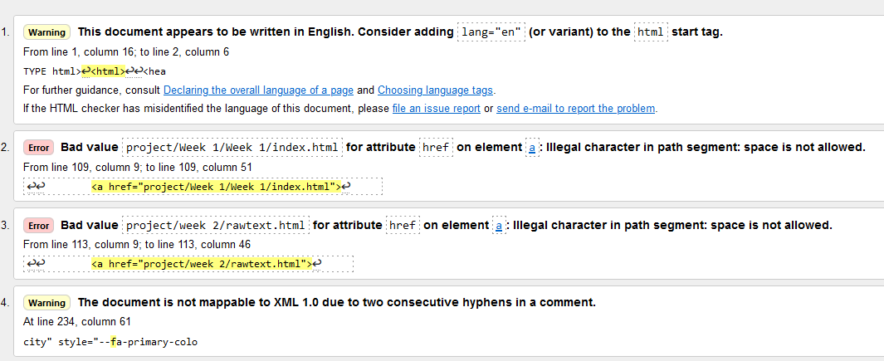

There is only these two that I could not change because it is the path that is like that.

***CSS Validator***

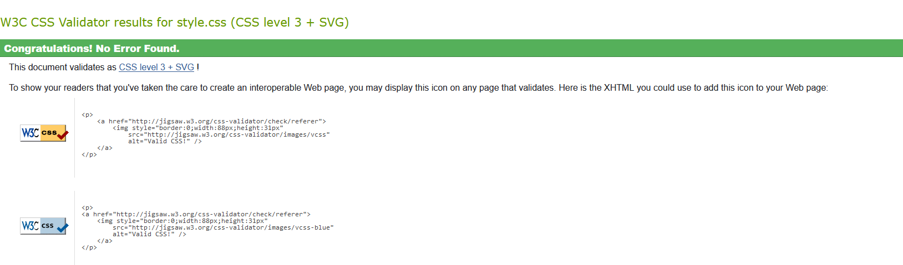

For CSS is ok, there is no error found in it.